
SAVE THE DATES
5-7 June, 2026 Tbilisi, Georgia
1st Georgian Puppet Theatre Showcase
UNIMA Georgia first planned to organize a Georgian puppet theatre showcase, during 5-7 June, 2026.
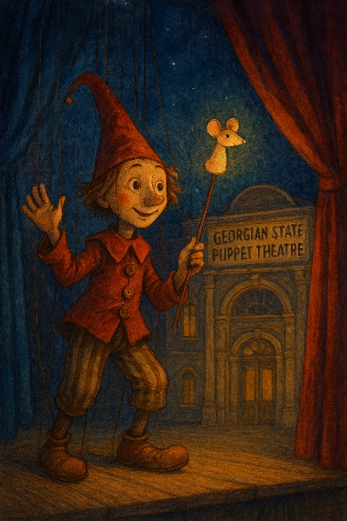
In Georgia operated 7 state puppet theatres, around 5 private theatres, puppet projects at the drama theatres and many independent projects. You can find a mix of adult and children shows, as well as a diversity of the forms like traditional puppets, marionettes, hand shadows and finders theatre.
We would like to invite puppet and experimental theatre festivals, programmers, producers who are open for partnership, co-productions exchange and networking.
Selected guests based on applications, will be funded with accommodation, meals, transportation and free access to all programs.
We are looking forward to receiving your applications for participation, places are limited.
Deadlines for applications 20 April, 2026
Organisers are: UNIMA Georgia, in close cooperation with ITI Georgian Centre and Georgian Puppet Theatre Union.
Artistic Director of the program: Nikoloz Sabashvili
Program Curator and producer: Dr. Levan Khetaguri
E-mail – unimageorgia@gmail.com

1st Georgian Puppet Theatre Showcase
5-7 June, 2026 Tbilisi, Georgia
Application form
I would like to apply to attend Showcase
Name
Surname
Occupation
Institution
Functions at the Institution
Whats up
E-mail
Country
City
I need to be covered /please mark/
Accommodation – 5 June, 6 June, 7 June
Meals - 5 June, 6 June, 7 June
Airport transfers
E-mail – unimageorgia@gmail.com

