

|  |
| --- |
| Registration form for the International  Puppet Theater Virtual Festival |
| Author |
| director |
| Country |
| City |
| Director`s field of study ( for the people who are the student is require) |
| Director`s University ( for the people who are the student is require ) |
| The name of group or company |
| Director's brief resume |
| Address |
| Phone number |
| Email |
| fax |
| the brief scenario |
| About the director (English and Persian) |
| Name of group members |



**Satisfaction form**

I ...................... Director of the show .................... to the national code ................ I confirm my satisfaction with the screening of my puppet theater film on the platforms approved by the festival.

**Date**

**Signature**

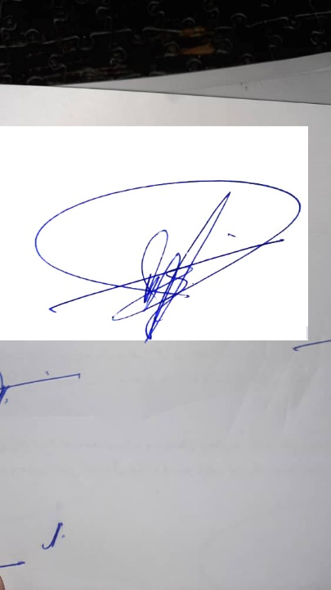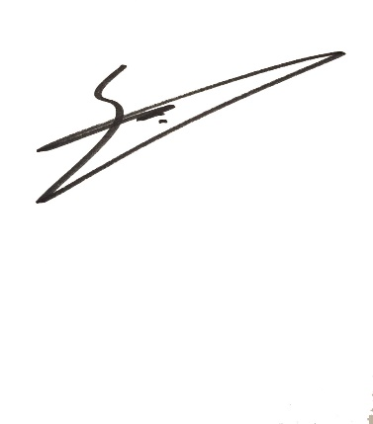

**Festival Advisor**

**Poupak Azimpour Tabrizi**

**President of Festival**

**Bahram Behbahani**

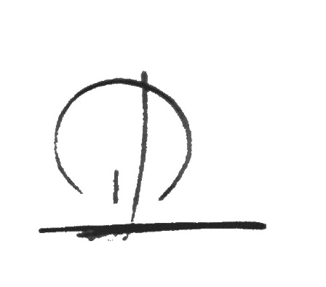

**Director of International Affairs**

**Sheyda Lotfi**